Customer LifeTime Value (CLTV) - Main Goal
Goal: analyze past behavior of customers to estimate economic value that customers will have in the future

Methodological approach: 3 different approaches
- Traditional approach
- 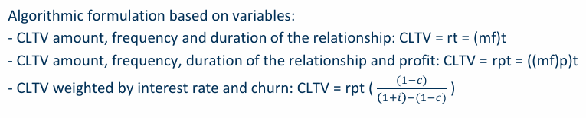
  - m: average spending of customers
  - f: average purchase frequency
  - t: average duration of the relationship
  - r: revenue of a customer (r=mf)
  - p: company’s profit percentage
  - i: discount rate (interest applied to reduce future cash flows, usually 10%)
  - c: churn rate (percentage of customers who leaving the company in the period)
- Predictive approach - ML
- 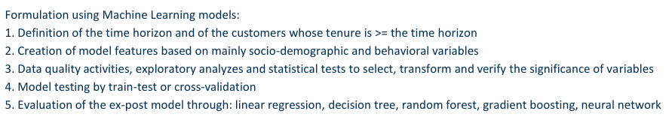
- Predictive approach - Econometric models
- 